Naval Dockyards Society Conference: 4 April 2020
Where Empires Collide:
Dockyards and Naval Bases in and around the Indian Ocean
National Maritime Museum, Greenwich
Web: https://navaldockyards.org/
Facebook: NavalDockyardsSociety
Twitter: @DockyardSociety
This one-day conference will examine the role and scope of naval bases and naval support facilities in and around the Indian Ocean.  Were bases built to defend colonies, control colonies, or to attack the enemy? Were they to suppress local forces, engage companies threatening the British East India Company or as adjuncts to European struggles? How useful were they to their founding countries in the 17th–20th centuries? How has their heritage developed?  Seamen of the early nineteenth century Omani navy seen during a visit to Portsmouth Dockyard | 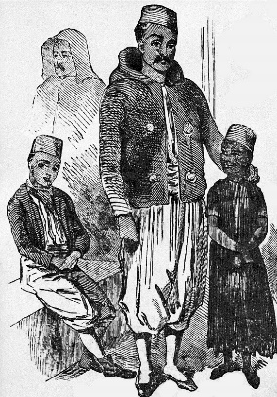
Programme:
Philip MacDougall In Support of Napoleon’s Great Adventure - the navy of Tipu Sultan. Its design, construction and purpose
Karim Malak The Anglo-Egyptian Naval Encounter: A new history of Egypt and Britain
Patricia O’Sullivan Out of the Shadows - the Police Force of Hong Kong’s Royal Naval Dockyard
Amit Gupta Indian Naval Shipbuilding and Bases: The impact of heritage and being a successor state
David Erickson The Contribution of Simon’s Town to Diplomatic & Naval Affairs, 1795–1957
Erik Odegard Dutch, French and British planners and Trincomalee naval dockyard
Richard Holme Trincomalee in the twentieth-century: The use of floating docks in the Indian Ocean
Robert Ivermee The Hooghly River and the limits of colonial power: European dockyards and naval bases in Bengal
Benjamin Jennings 'The richest and most fruitful island in the world': The allure of Madagascar and French ambition at Fort Dauphin 1643–1674

Cost: £45.00 includes buffet lunch, teas and coffees
Concessions £40.00 NDS members, retired, unwaged; £20.00 FT students
Please return booking form and cheque by 28 March 2020 to the Treasurer: David Jenkins, 5 Beeby Way, Carlton, Bedfordshire, MK43 7LW Or:

Go to PayPal website and ask to send money. Enter email: ndstreasurer@hotmail.co.uk; enter amount, Payee Reference: INDIAN OCEAN CONFERENCE, click OK; confirm your details to this email address.
Other enquiries to Dr Ann Coats, 8 Cromleigh Way, Southwick, BN42 4WG avcoatsndschair@gmail.com
National Rail 08457 484950 http://www.nationalrail.co.uk/ ; Transport for London: 0343 222 1234 https://www.tfl.gov.uk/ ; National Maritime Museum, Romney Road, Greenwich, SE10 9NF http://www.rmg.co.uk/national-maritime-museum/ Note: there is no parking at the Museum

……………………………………….…………………………………………………………………………………………………
2020 NDS Conference booking form:

I enclose a non-refundable cheque for £45.00/40.00/20.00 to Naval Dockyards Society/paid by PayPal:

Please indicate affiliation/concession: NDS member / institution / student / retired / unwaged
Please confirm/delete as required: I/We am/are/not disabled / have a medical problem of which NDS should be aware (specify):
State dietary requirements:

All names attending………………………...…………………..………………………………………………………………
Address………………………………………………………………………………………………………………………………...…..……………………………………………………………………………………………………………………………………
Telephone………………………………………..……………Email……………………………………………………….…....
Signed………………………………………...…………………………………..………………..…...…Date…………………

