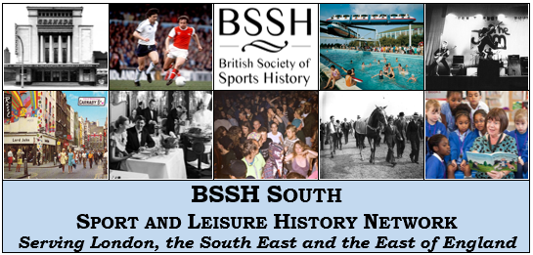

SUMMER 2015 WORKSHOP
Leisure and Coasts, Ports and Waterways
University of Portsmouth, Saturday 13th June 2015
In collaboration with the University’s Port Towns and Urban Cultures Group

Time | Programme
9:30 – 10:00 | Registration
10:00 – 11:30 | Panel 1: Seaside Resorts
 | Speakers: | Dr Rachael Johnson (University of Bradford)  ‘On Board a Margate Hoy’: Travelling to Kent's Seaside Resorts, c. 1760–1840
Leo Bird (University of Sheffield)
Variety-on-Sea: End of the Pier Shows and the Seaside Comedy Industry, 1945–1960
Dr Anya Chapman (University of Bournemouth)
The Seaside Pier as a Barometer of Changing Trends in Tourism and Leisure
Dr Paul Gilchrist (University of Brighton)
Heritage Trails at the UK Seaside Resort: The Cultural Politics of ‘Claims to Fame’
11:30 – 11:45 | Break

11:45 – 1:15 | Panel 2: Sports in Coastal Areas
 | Speakers: | Mark Rowe (De Montfort University)  A Cold Collation in a Spacious Tent: Cricket in Victorian Torquay and Bournemouth Compared
Paul Wheeler (University of Chichester)
An Ambitious Club on a Small Scale: Royal Isle of Wight Golf Course
Geoff Swallow (Manchester Metropolitan University)
Storming the Malakoff: The St Ives Swimming Matches and the Civic Project of Modernity
Professor John Nauright (University of Brighton)
To There and Back: The Great Fogo Island Punt Race in Newfoundland
1:15 – 2:15 | Lunch
2:15 – 3:45 | Panel 3: Leisure in Port Town Communities
 | Speakers: | Dr Brad Beaven (University of Portsmouth)  From Jolly Sailor to Proletarian Jack: The Remaking of Sailor's Leisure and Sailortown in Victorian London
Dr Melanie Bassett (University of Portsmouth)
The Role of Late-Victorian and Edwardian Commercial Leisure and Sport in the Formation of Port Town Civic Identity
Chris Spackman (University of Portsmouth)
Coastal Leisure at the Summer Camps of the Boys’ Brigade from Port Towns, c. 1886–1933
Jane Smith (Kings College London)
The Development of Portsmouth’s Lidos, 1920–1960
3:45 – 4:00 | Break
4:00 – 5:00 | Keynote Lecture
 | Speaker: | Professor Peter Bailey (University of Manitoba)  Roller Skates to Ragtime: Americanisation and Leisure in Britain, 1860–1920
5:00 – 5:30 | Discussion: The Future of BSSH South in Hampshire

This workshop is organised by the British Society of Sports History's South of England Sport and Leisure History Network (BSSH South), which aims to bring together individuals in Greater London, the South East and the East of England interested in the history of leisure in all of its forms.

It is being co-hosted with the Port Towns and Urban Cultures group at the University of Portsmouth, founded in 2010 to examine the social and cultural impact of life in port towns from the eighteenth century onwards: http://porttowns.port.ac.uk/.

Registration Form

Details
Name:
Affiliation:
Email:
Do you have any dietary requirements? If so, please specify below.

The delegate fee for attending the workshop (including lunch and refreshments) is £25.
Please fill this form in and send it as an attachment to the workshop organisers at bsshsouth@gmail.com by Thursday, 28 May 2015. We ask that you pay your delegate's fee by cheque; please write it out to 'The Sport and Leisure History Seminar' and send it to Dion Georgiou, 1 Edwards Mews, London N1 1SG.

You can also join the BSSH South mailing list at https://www.jiscmail.ac.uk/cgi-bin/webadmin?SUBED1=SPORT-AND-LEISURE-HISTORY&A=1, visit our website at https://bsshsouth.wordpress.com, and follow us on Twitter at https://twitter.com/BSSHSouth.

